10-2: Single-Row Subqueries.

Try It / Solve It

1. Write a query to return all those employees who have a salary greater than that of Lorentz and are in the same department as Abel.

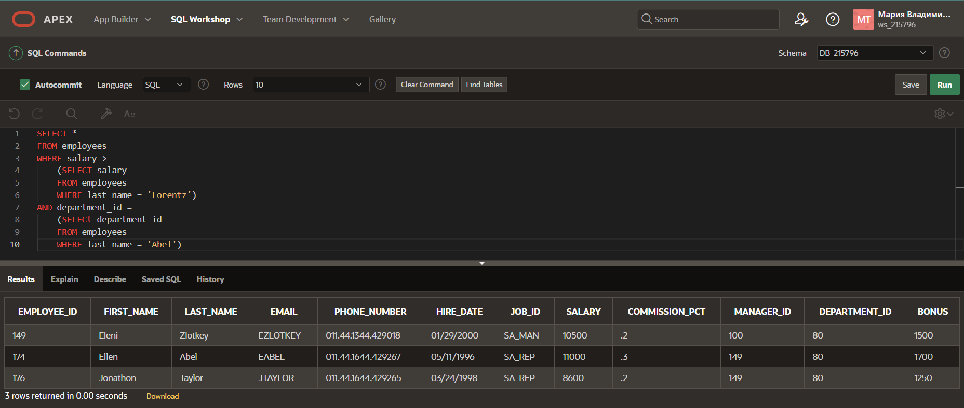

1. Write a query to return all those employees who have the same job id as Rajs and were hired after Davies.

1. What DJs on Demand events have the same theme code as event ID = 100?

1. What is the staff type for those Global Fast Foods jobs that have a salary less than those of any Cook staff-type jobs?

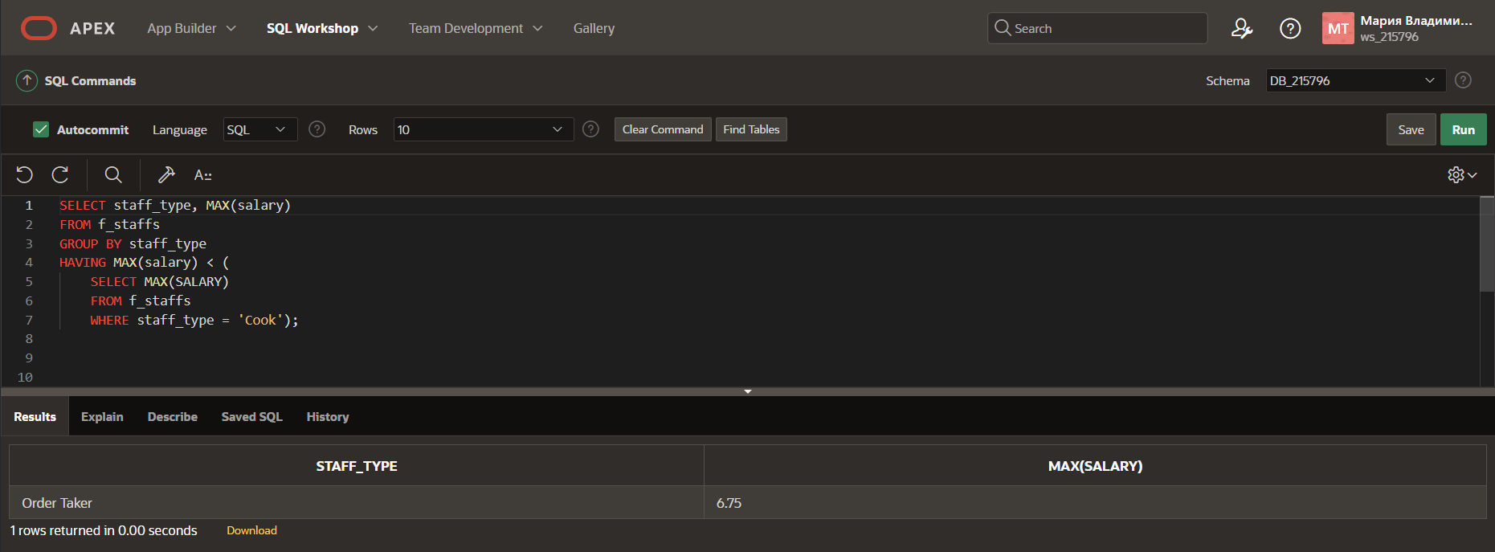

1. Write a query to return a list of department id’s and average salaries where the department’s average salary is greater than Ernst’s salary.

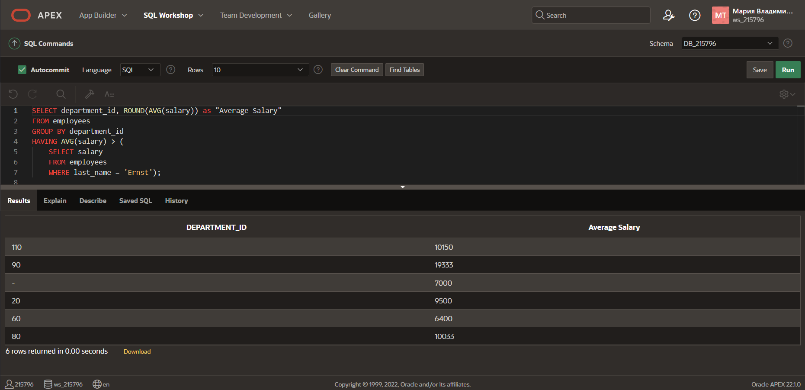

1. Return the department ID and minimum salary of all employees, grouped by department ID, having a minimum salary greater than the minimum salary of those employees whose department ID is not equal to 50.

